

Subject: Programming with Java
ASSIGNMENT No :2
TITLE :Develop a Java application demonstrating the use of default, parameterized, and copy constructors for object initialization and data management.
Name:-Avdhoot Mohite Class:CSE
PRN:25070122056 Batch:2025-29
Assignment 2: Methods and Static Members
Problem Statement
Develop a Java application demonstrating the use of default, parameterized, and copy constructors for object initialization and data management.
Learning Objectives
- Understand the concept and purpose of constructors in Java.
- Differentiate between default, parameterized, and copy constructors.
- Initialize objects using different types of constructors.
- Learn how constructors simplify object creation and initialization.
- Understand the importance of constructor overloading.
- Implement object copying using a copy constructor.
- Improve code readability and maintainability through proper object initialization.
- Develop Java programs that demonstrate effective data management using constructors.

Theory
A constructor is a special method in Java that is automatically invoked when an object of a class is created. Its primary purpose is to initialize the object's data members. A constructor has the same name as the class and does not have any return type, not even void.
Constructors help ensure that objects are created in a valid state by assigning initial values to their instance variables. They improve code organization by eliminating the need for separate initialization methods.
Java supports constructor overloading, where multiple constructors with different parameter lists can exist within the same class. This provides flexibility in object creation

Code & Output Screenshots
1)Default Constructor
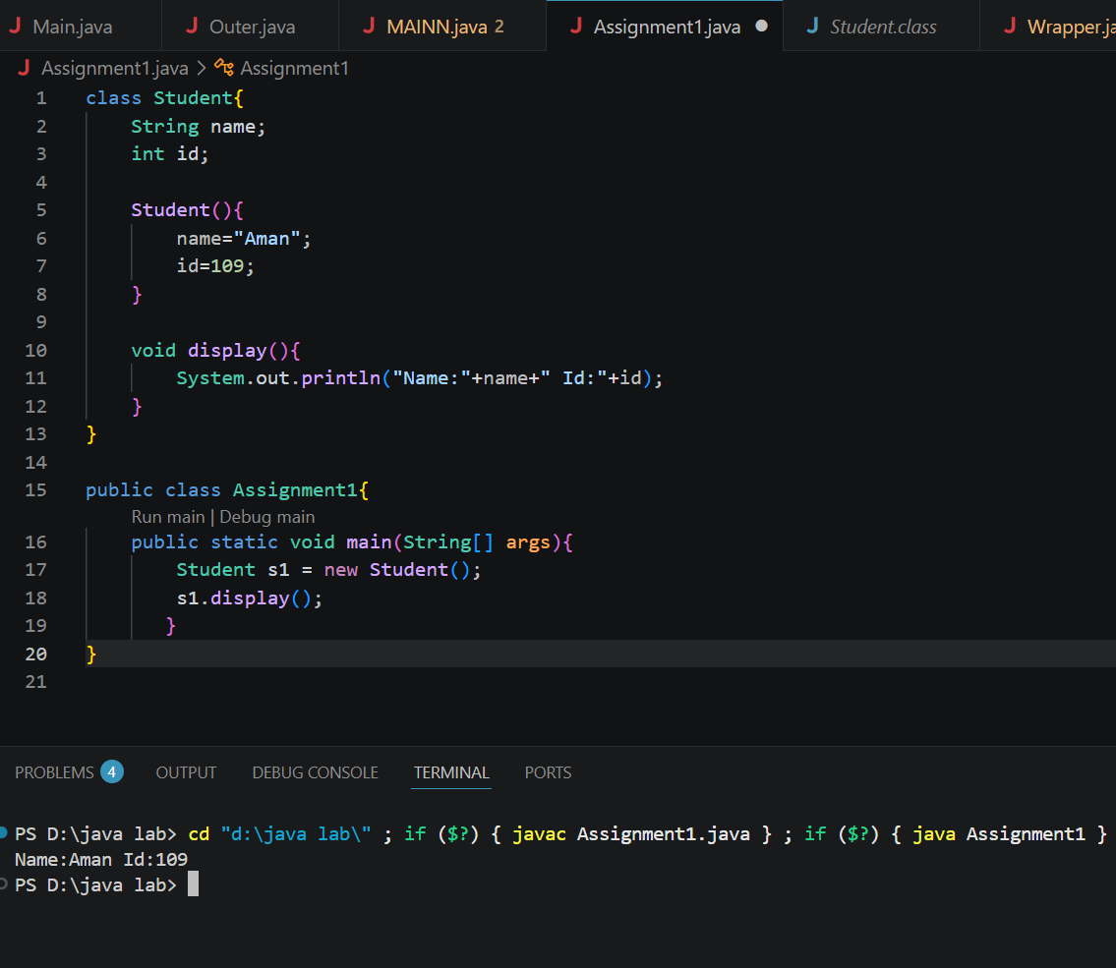

2)Parameterized Constructor
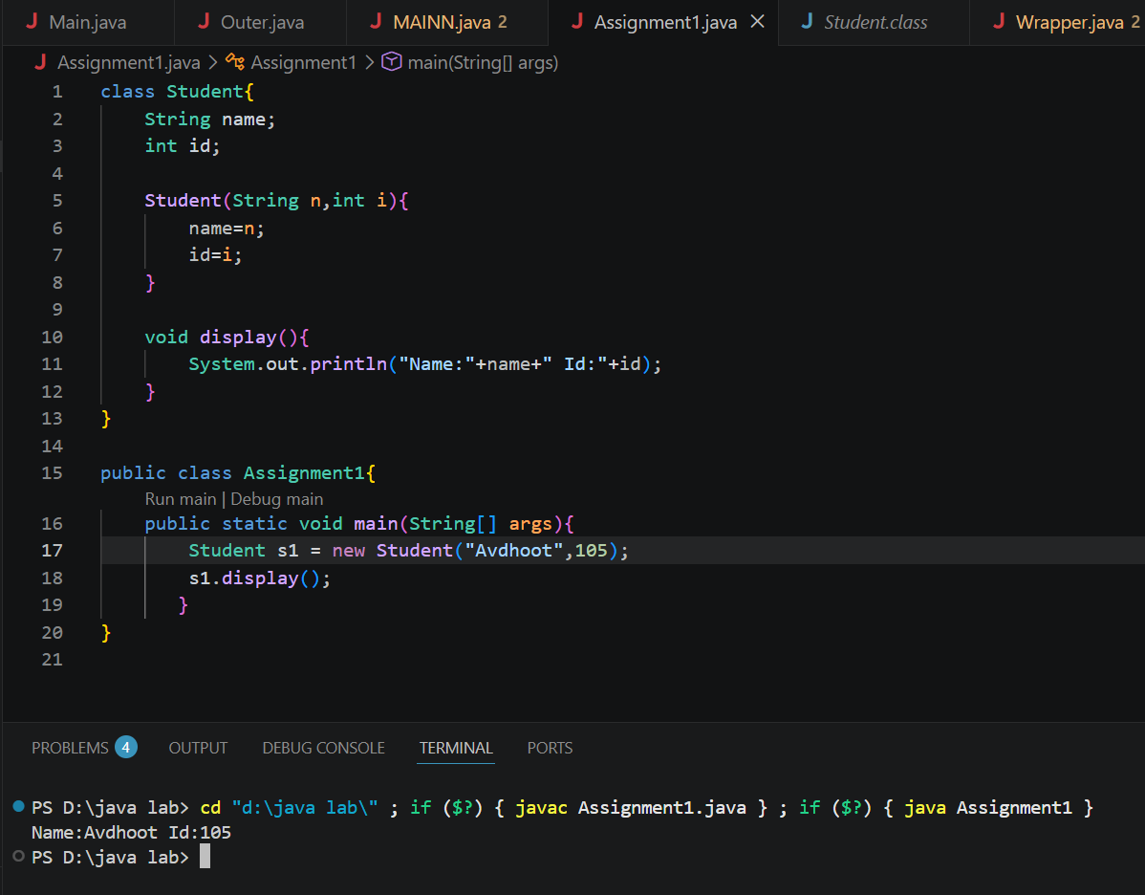

3)Copy Constructor
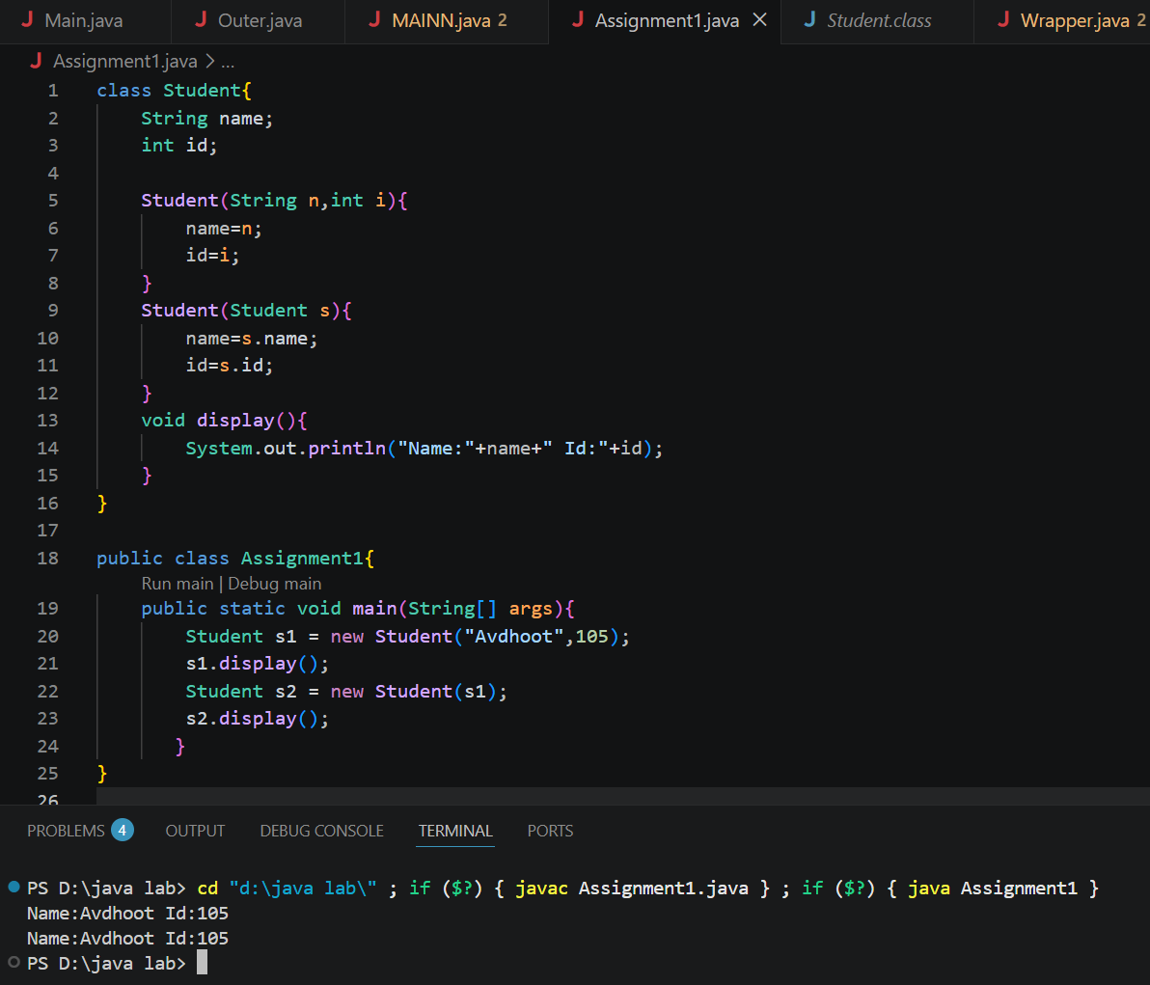
Outcome
The outcome of this assignment is the successful understanding and implementation of default, parameterized, and copy constructors in Java. It helps in developing the ability to initialize objects efficiently, manage object data effectively, and understand the concept of constructor overloading. The assignment also strengthens the understanding of object-oriented programming principles and improves the ability to write clean, organized, and reusable Java programs for real-world applications.

Conclusion
This assignment demonstrated the practical use of default, parameterized, and copy constructors in Java for object initialization and data management. It helped in understanding how constructors simplify the process of creating objects with appropriate initial values and improve code organization. The implementation of different constructors and constructor overloading provided flexibility in object creation, while the copy constructor illustrated how object data can be duplicated effectively. Overall, the assignment strengthened the understanding of constructors as an essential feature of object-oriented programming and their importance in developing efficient, reliable, and maintainable Java applications.

Exercise
1. Create a Student class using default and parameterized constructors to initialize student name and roll number.

Code:
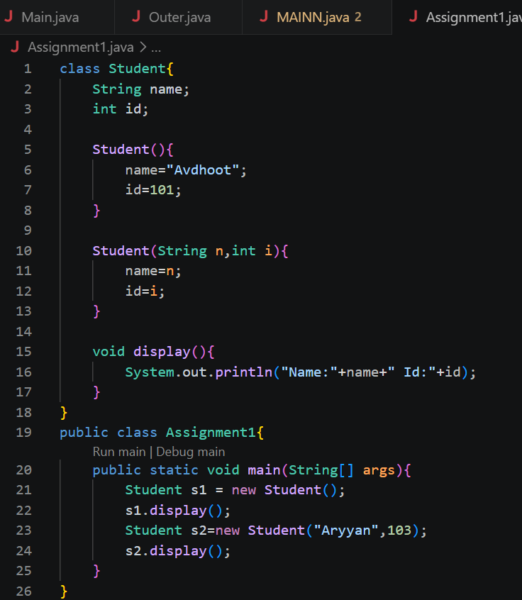

Output:
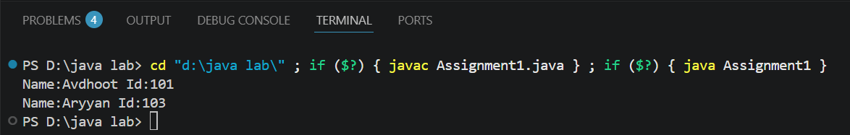

2. Develop a Mobile Phone Inventory System using different constructors to initialize mobile details and create duplicate object records.
Code:
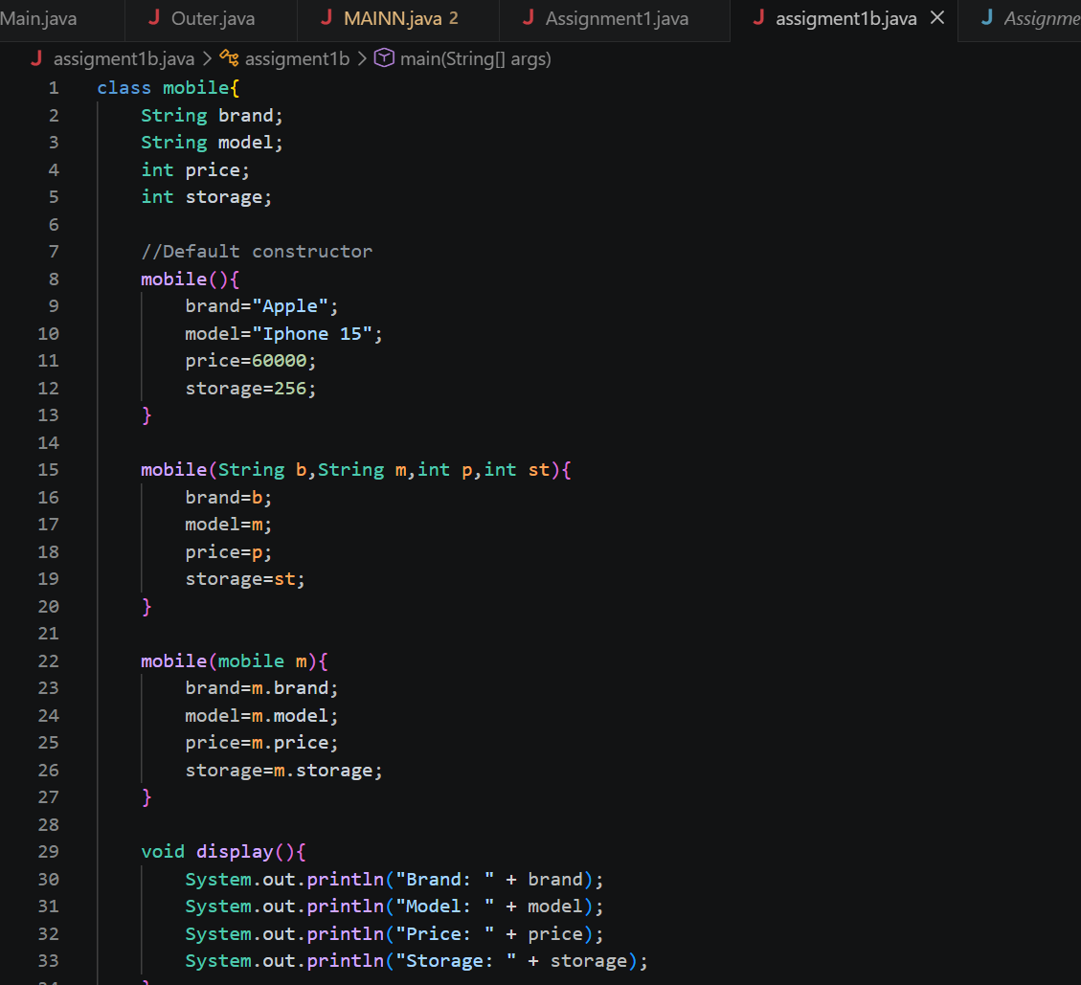
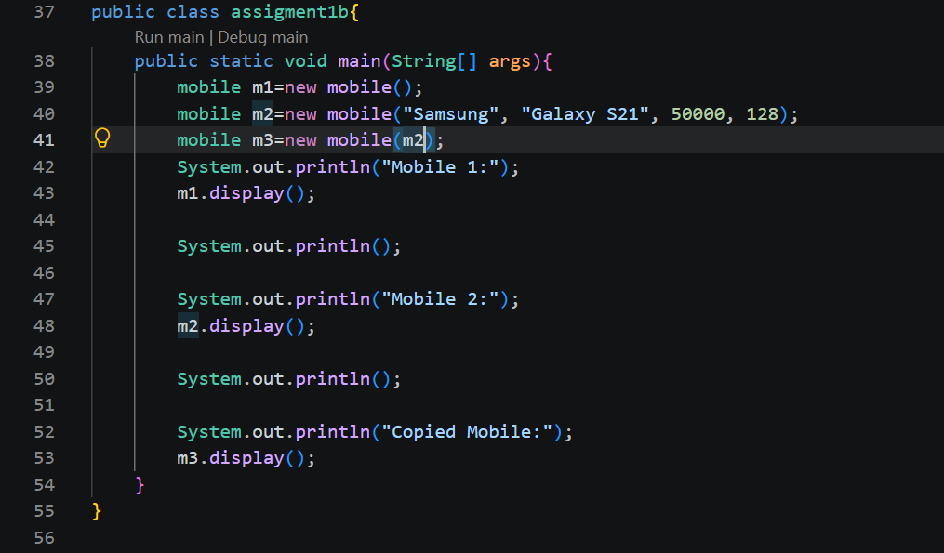
Output:
